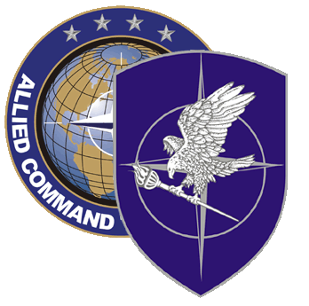
NATO SCHOOL: Global Leader in Multinational Military Education and Individual Training

N3-67 NATO Military Police Officer Course

The aim of this course is to provide basic knowledge and to teach the principles of operational level MP planning in support of NATO led operations within the wider context of NATO decision-making at the strategic level.

Course Length: 1 week

Offerings per year: 1

Class Size: Max 55 / Min 25

Security Clearance: NATO RESTRICTED Releasable EU

Rank and Characterization of Students:

Officers (OF-2 to OF-5) or civil equivalent assigned or selected for assignment to a MP or MP related appointment in a NATO HQ or comparable appointment in a NATO Country; or

Civil Policemen acting at the operational level; or

Personnel outside of the above criteria must obtain a written waiver from Office of Primary Responsibility (OPR) (MP SHAPE).

Prerequisites:

- Language proficiency: English IAW STANAG 6001 3333

- Computer skills: Student must be familiar with MS Word and Power Point.

Course Objectives:

At course completion, the student should be able to:

- Describe the NATO decision-making process at the operational level.
- Explain how campaigns and major operations are planned, sequenced and directed in order to achieve the desired military strategic end-state.
- Explain the NATO Operational Planning Process.
- Explain the NATO MP Planning Process at the operational level.
- Explain NATO MP Doctrine and concepts at the operational level.
- Explain the MP current/future capabilities available to a joint/combined commander at the operational level.
- Conduct MP Planning at the operational level, and produce a detailed MP Annex to an OPLAN

